Submitted PO, adjustment

On Update:

1. Can Remove item

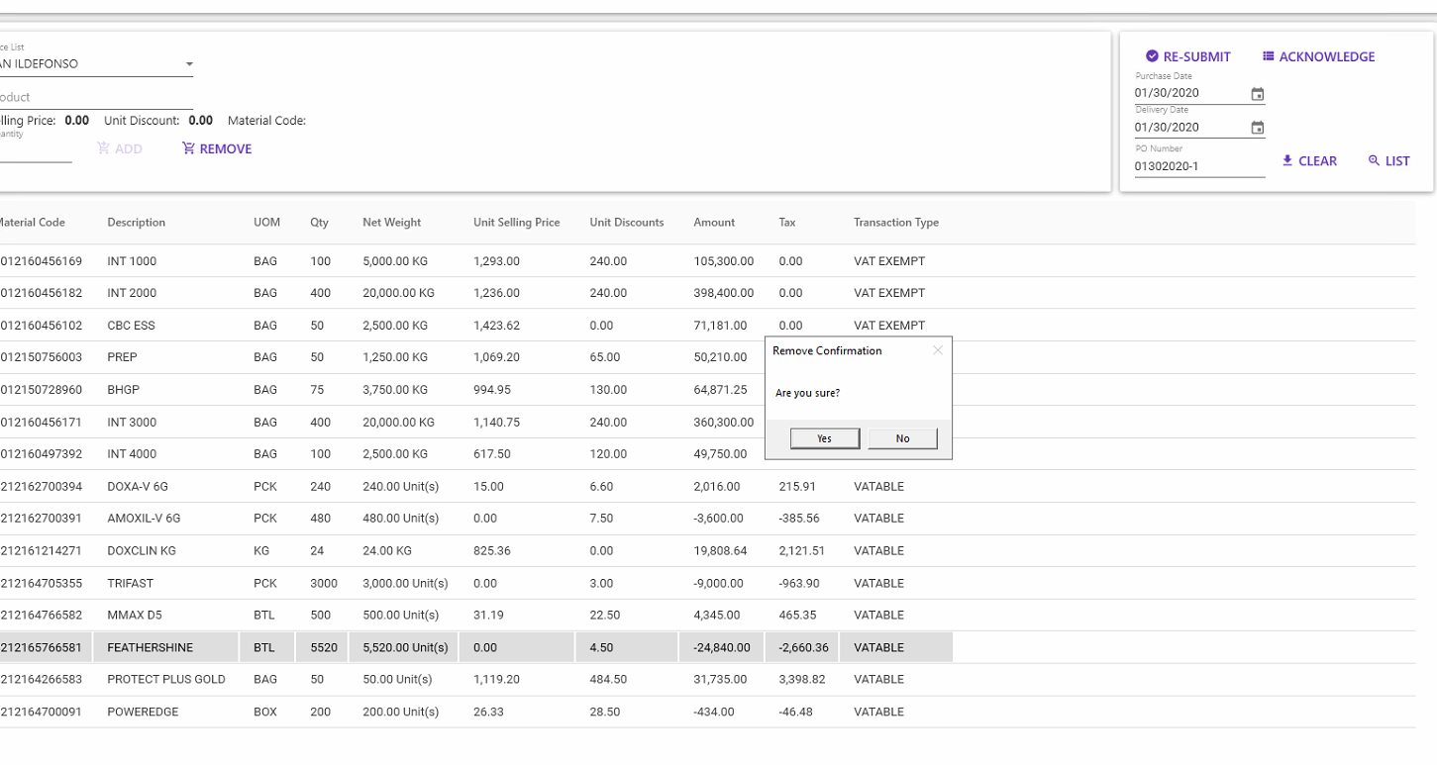

1. Can adjust the selected record

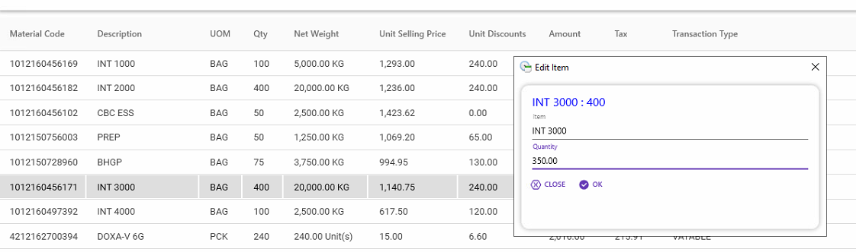

1. Can Re-Submit the PO by clicking RE-SUBMIT

